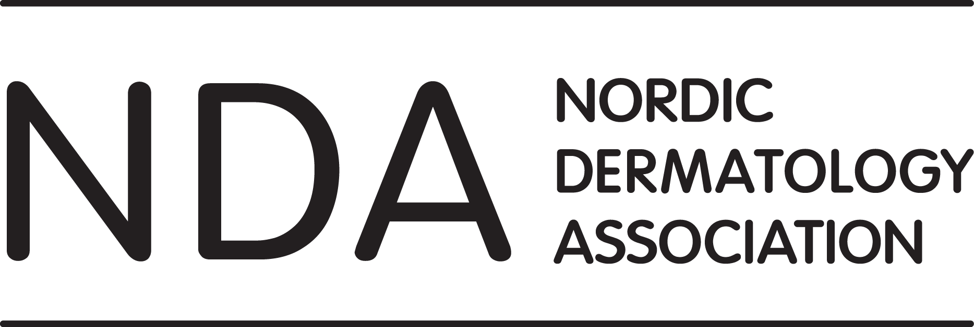

NDA Board Meeting Minutes
Date: Saturday October 12, 2019 at 09:00-12:00
Place: AC Hotel by Marriott Madrid Feria, Madrid, Spain

Present:
Denmark: Tove Agner, Deirdre Nathalie Dufour
Finland: Kaisa Tasanen-Määttä, Teea Salmi, Katariina Hannula-Jouppi
Norway: Katarina Zak Stangeland, Petter Gjersvik
Sweden: John Paoli

Not present: Lars Iversen, Gregor Jemec, Baldur Baldursson, Bolli Bjarnason, Usha Hartgill, Ada Girnita, Johan Dahlén Gyllencreutz, Agneta Andersson

§1 (74) Welcome and opening of the meeting (JP)

JP chaired the meeting.

§2 (75) Approval of past board meeting minutes and review of actions requiring follow-up (JP,PG)

The minutes from NDA board meeting in Gothenburg in May 2019 were approved. All actions requiring follow-up were reviewed.

§3 (76) Quick updates from the national societies (LI, KTM, BB, KZS, AG)

These updates are partly based on post-meeting reports.

Denmark:
- DDS has initiated a review of the educational program for residents in dermatology.
- Ongoing work on national guidelines and patient information material.
- New working groups have been established.
- The board is in dialogue with the National Board of Health in Denmark regarding Mohs surgery and the treatment of bullous disease.

Iceland:
No member of the Icelandic society board was present. No report received by October 22.
Finland:
- The Finnish society will have its Autumn Meeting on Nov 14-15 2019 in Helsinki in collaboration with Finnish Society for Pulmonary Specialists, with scleroderma and allergology as topics.
- The society is currently up-dating its bylaws.
- The national laws and regulations regarding specialization have changed. The first digital specialist examination was held in April 2019, and it worked very well.
- National application of study rights and selection of students/residents by individual scorings occurred for the first time this autumn. Interviews will be performed in November 2019.
- Specialist trainings will be changed from time-based to learning-based, but the exact timetable for implementation is still unclear.

Norway:
- From Sept 1st, there is a new board with five members that will serve a two-year term. Updated information on the new members can be found on the NDA website.
- There is still uncertainty regarding changes in the education of new specialists and residents. All university hospital departments are working closely together on this matter.
- A new committee for continuous medical education for specialists will start planning courses and advanced training programs.
- As in previous years, there is an up-coming Autumn Meeting in Oslo at the end of October with international speakers. The annual research seminar will be held in January 2020 and the Spring Meeting with the general assembly in April 2020.
- Dupilumab has still not been approved for reimbursement in Norway, but we expect a positive outcome in the near future.

Sweden:
- Many specialists are retiring, and the number of residents is increasing.
- The economy of SSDV is stable.
- Ongoing discussion on meeting structure, including spring meeting every third year possibly being combined with Nordic congress.
- Changes in the curriculum for medical students in Gothenburg.

§4 (77) Economy (KZS)

KZS reported on the financial status of NDA. Results for 2019 will be >230,000 SEK depending on the final results from the NCDV in Gothenburg. The expected surplus from the NCDV will be approximately 600,000 SEK, which will be split equally between the NDA and the SSDV. Work on the NDA budget for 2020 is in progress.

The congress organizing company for the NCDV in Gothenburg has asked JP for payment for 40 extra hours (appr. 36,000 SEK). The board decided to accept 20 extra hours (appr. 18,000 SEK) depending on the approval from the SSDV board. JP will follow up.

§5 (78) Report from the Education Committee (TA)
TA reported on the status of on-going, planned and potential NDA courses.
- Skin surgery: 6th Nordic course on Skin Surgery will be held in Copenhagen on November 7-8, 2019. A 7th course is planned, probably in 2021.
- Dermatoscopy: 4th Nordic Dermoscopy Course was held in Gothenburg, April 2019. A 5th course is planned for April 2-3, 2020.
- Lasers in Dermatology: A 2nd course will be held in 2020.
- Global dermatology: At present, there are no plans for a repeat course on global dermatology.
- Nordic Course on Virtual Dermatopathology has been held twice in Reykjavik. Plans for a 3rd course in 2020 have been cancelled due to several obstacles. A course in classical dermatopathology could be considered.
- Mucosal disease: Finland is presently considering holding a course on mucosal disease.
- STD: Usha Hartgill and her STD team in Oslo is willing to organize a Nordic course on STD in 2022 or 2023. KZS will inform Eidi Christensen, Norway’s representative on the NDA Educational Committee.
- PDT: Presently, a Danish course on PDT is held regularly.
- Pediatric dermatology: A course on pediatric dermatology and genodermatoses is considered in Finland
- Contact dermatitis: TA will approach the organizers of the Danish course on contact dermatitis whether this course could be made a Nordic course.
- Research course: Not at the moment.
JP drew attention to a IDS Regional Meeting in Warsaw on October 15-17, 2020. Nordic dermatologists should be encouraged to attend. National representatives in the NDA board should inform their members of this meeting.
TS will contact the national society educational committees in order to increase communication and cooperation. This information should be put up on the NDA website: How are resident and CME education organized in each country
§6 (79) Website updates (JP, PG, AA, all)

Agneta Andersson has informed JP that she is close to retirement and will work only part-time at Acta from Jan 1st, 2020. The Acta board has decided to cease activities not related to the publication of Acta. In January 2020, AA will start her own company and has offered to continue her present administrative functions for NDA (with these exceptions: no presence at NDA board meetings, not doing major changes to the NDA website, and not booking meeting rooms for board meetings) for at least one year for 25,000 SEK (31,250 SEK including VAT), which is half the current price of 50,000 SEK (62,500 SEK including VAT).

The board accepted her offer. Booking conference rooms for NDA board meetings will be done by KZS. Minor changes to the NDA website structure and functionality will be done by AA before the end of 2019. JP will follow-up regarding setting up a contract with AA.

§7 (80) Forum for Nordic Dermato-Venereology (AA, JP)
The board of Acta Dermato-Venereologica has decided to cease the publication of Forum for Nordic Dermato-Venereology, which is the offical journal of NDA. Unpublished manuscripts will probably be published in a single last issue in the coming months.
The NDA board found it unrealistic to continue the publication of Forum. Future manuscripts could be published on the NDA website, especially summaries of new PhD theses. Similarly, national society updates, meeting and course reports, editorials, summaries from scientific meetings, reports on on-going clinical or research projects could be published on the NDA website.
JP and PG will write an editoral for the last issue of Forum. All NDA board members are encouraged to attract future news reports for the NDA website. JP will prepare a template for PhD thesis reports.
§8 (81) NCDV 2022 in Copenhagen (GJ, LI)
GJ and LI were not able to attend the meeting. TA reported on the first plans for the NCDV in 2022.
GJ proposed the following:
- Suggested date: May 18-20, 2022.
- General assembly of SSDV and NFDV, preferably also the Sping Meeting of DDS, to be integrated with the congress.
- Congress to be run from lunch 18th to lunch 20th (in Danish: Frokost).
- CAP Partners will be technical organizer and will present its first outlines at an October 18th meeting.
- Parallell sessions for nurses.

The suggested dates are not ideal. A NDA board meeting would have to be held on May 17th, which is the National Day in Norway with celebrations until late at night. A NDA board meeting Wednesday morning would require moving the SSDV and NFDV General Assembly meetings to Friday afternoon, which will not be acceptable for SSDV.

The NDA board decided to ask for new suggestions for congress dates, as well as a time-line for the congress preparations and a brief outline of the organisational model. TA will contact GJ on this, copying in JP and PG.

§9 (82) ILDS Membership (JP)

JP has submitted the application for ILDS affiliated membership for NDA in June. JP will follow up according to ILDS’ response.

§10 (83) NDA Research committee (TS)

The board decided to establish a NDA Research Committee with TS as interim leader. Her first task is to recruit one committee member from each membership country. TS will send a draft e-mail text to JP/PG regarding the recruitment of potential committee members. Further plans to be discussed on the next NDA board meeting in March 2020.

§11 (84) Mohs surgery in Denmark

The Danish Health Authority (i.e. Sundhetsstyrelsen) has issued a PM stating that Mohs surgery should only be performed in rare cases of skin cancer and only in the context of multi-disciplinary skin cancer teams. This PM is a threat to both Danish and Nordic dermatology, but also to dermatology in other European countries. JP has offered help and support from NDA and ESMS, but the DDS has sent their response (which is available on the DDS site) without such support.

The NDA Board decided to follow the development closely and reiterated its commitment and support for DDS and Danish dermatologists. TA will keep the NDA board up-dated, and the topic discussed on the next NDA board meeting.

§12 (85) Other issues

JP reported from the EADV board meeting in Madrid. No applicants for EADV board membership had been received from Denmark, Norway and Finland. The national societies in NDA should make sure that there will be at least one applicant from each country.

The NDA board discussed the possibility of establishing some kind of awards for long-term and/or particularly active NDA members, but decided against.

§13 (86) Next meeting (All)

The next NDA board meeting will be held at Kastrup Airport, Copenhagen, on Friday March 27th , 2020, from 14:00 to 17:00. The meeting will start with a luncheon at 13:00. This will ensure the possibility for Icelandic board member to attend. KZS will book a conference room at the Clarion Hotel Copenhagen Airport.

Petter Gjersvik
NDA Secretary General

Numbers in brackets are numbers used in the original agenda
Minutes reviewed by JP on October 16, 2019
Minutes sent to all NDA board members on October 23, 2019

